**Dynamic Web Programming midterm exam**

**Time: 2hrs**

**Guidelines for submission**

1. Create one folder including all the files associated with your submission.
2. The folder should include a readme.txt which must include the names of both the team members.
3. Zip/Compress and folder and upload it on the provided link
4. Good luck!

**Q.1. (14 marks)**

Write the HTML and CSS code necessary to recreate the following appearance on-screen.

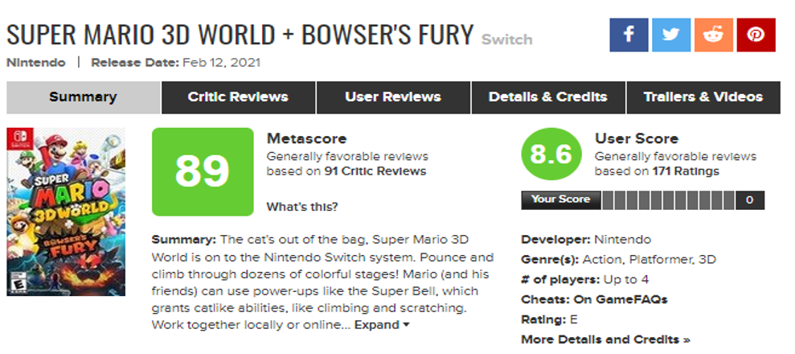

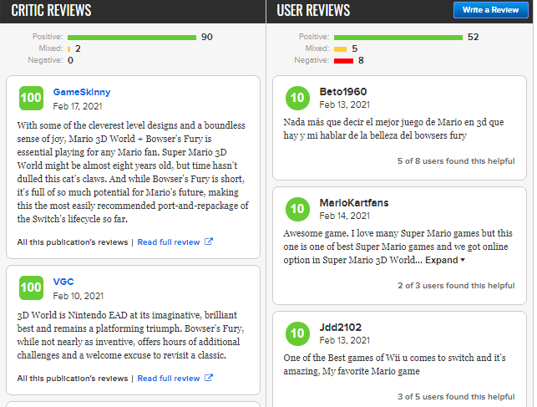

Write **valid code** that would pass the W3C validators .The necessary images have been enclosed. Your creation should as close as possible to the given layout, positioning and overall appearance. You can decide the font size and font family you want to use to bring it close to the given appearance. The text in the critics and user reviews doesn’t have to match to the one written on the page. You can write your own reviews. At least five reviews must appear as shown.

The links in the menu for Critic reviews, User reviews, Details & credits, Trailers & videos are not supposed to work. This mean that you are not supposed to develop the web pages for Critic Reviews, User Reviews, Details & Credits, Trailers & Videos sections. You are expected to develop **one** HTML page which looks as above.

**Q.2. (6 marks)**

Consider a two-player game played with blocks of six different colours. One player (the encrypter)selects four blocks of different colours and places them in a certain order(leftmost through right most).This is the encrypted message, and is **not** shown to the second player (the decrypter). The decrypter then selects four colour blocks and places them in an order from left to right; this is the decrypter’s guess about what the encrypted message is. Next, the encrypter scores the decrypter’s guess by using the words black and white; these colours (black and white) deﬁne a score for the guess. A black point indicates that one of the guessed blocks is exactly right: right colour and in the right position. A white point indicates that a guessed block is the right colour but in the wrong position. So two black points and one white point would mean that three of the guessed blocks are of the right colour and that two of these are in the correct position within the guessed block ordering. Once a guess has been scored, the decrypter guesses a second time, and the encrypter scores this guess. (See Figure below of such a game after two guesses have been scored.) This continues until the decrypter fully guesses the secret code (score of four black blocks). Write a JavaScript program that allows the users to play the game.

A possible interface is suggested below, which shows a game after the user (decrypter) has made two guesses. The user clicks on a colour in the palette area and then on one of the holes in the Board area. The program then colours the background of that hole with the selected palette colour. The colour of a hole can be changed by clicking on a different colour in the palette and then clicking the hole. When the user is satisﬁed with the colours on the row representing the current guess (guesses proceed from bottom to top on the board), the Score Me button is clicked. The program then computes the score for that guess and displays it in the text box to the right of the guess. After the decrypter has made eight unsuccessful attempts, the decrypter is informed that he/she has lost the game. Otherwise, the decrypter is informed about the winning the game when the successful attempt is made.

